**Name: Veenu Agarwal(008718541)**

**Android Application Project: Remind Me!**

The aim of the project is to get hands on Android Application Development. Location Sensor, Google Maps API V2, Google Maps Direction API, Notification Service was used to accomplish project.

The project aims to provide the current location of the user and allows user to set some location as his point of interest. Based on location of user’s point of interest the user is provided with the route to destination. Map. Also, user can set reminder or alert for any location as his point of interest. So, when user reaches his or her point of interest, then phone starts vibrating to get user’s attention and fires notification with a message “You are near your Point of Interest”. The application was tested on emulator as well as on Android phone.

**HIGH LEVEL ARCHITECTURE:**

1. Implements Location Manger to get the current location of user.
2. Geocoder is used to get the latitude and longitude of point of interest location

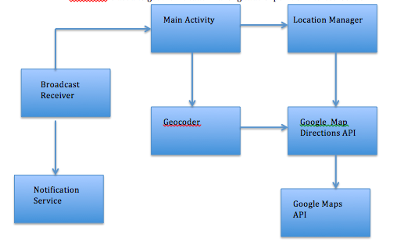

1. The latitude and longitude fetched from Geocoder and Location is fed into Google Map Direction API to extract the route between two locations.
2. Pending Intent retrieves the Broadcast receiver which is named as “Proximity Intent receiver”
3. Google Maps was used to
4. Broadcast receiver class is registered using to the main UI thread.
5. Notification Manager is registered on Broadcast receiver in order to fire notification to user.

**TESTING:** The application was tested on Android emulator as well as on Samsung Galaxy S4, platform Jelly Bean 4.3

1. 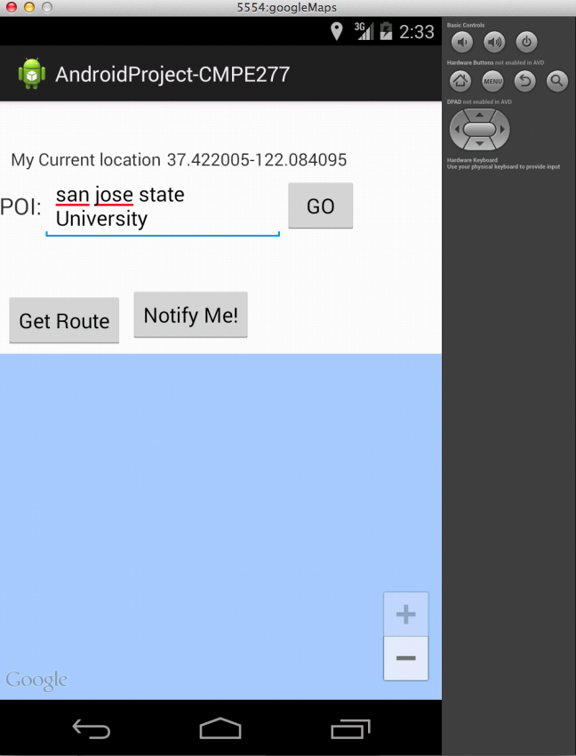

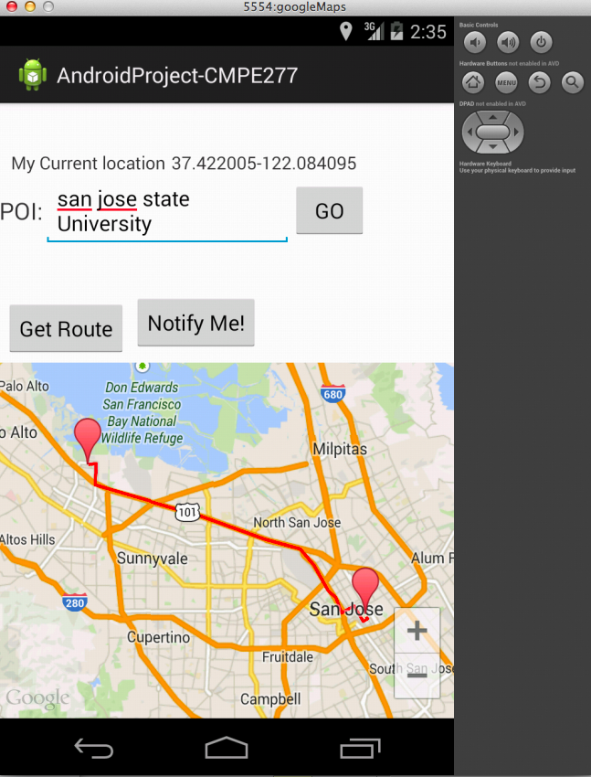

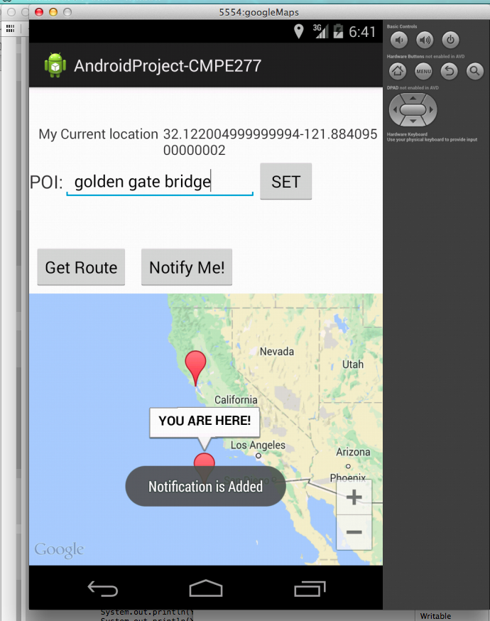

**In the above screen shot, Golden Gate Bridge has been set to point of interest, then a Toast message comes up with a message. So whenever the user is within 10 meters radius of point of interest, the phone starts to vibrate and fires a notification.**